**Module 4 – TDD using JUnit5 and Mockito**

**Exercise 1: Setting Up Junit**

1.Created a new Java project.

2. Added JUnit dependency.

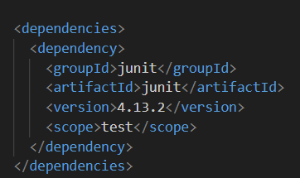

3.

|  |  |
| --- | --- |
| Calculator.java  package com.example;  public class Calculator {      public int add(int a, int b) {          return a + b;  }  } | CalculatorTest.java  package com.example;  import static org.junit.Assert.assertEquals;  import org.junit.Test;  public class CalculatorTest {      @Test      public void testAdd() {          Calculator calc = new Calculator();          int result = calc.add(2, 3);          assertEquals(5, result);      }  } |

**OUTPUT:**

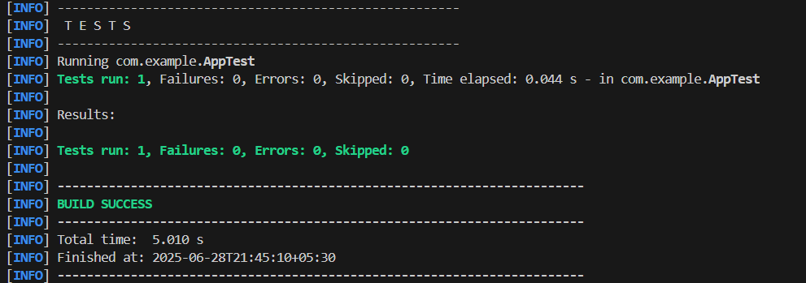

**Exercise 3: Assertions in Junit**

|  |
| --- |
| AssertionsTest.java  package com.example;  import static org.junit.Assert.assertEquals;  import static org.junit.Assert.assertFalse;  import static org.junit.Assert.assertNotNull;  import static org.junit.Assert.assertNull;  import static org.junit.Assert.assertTrue;  import org.junit.Test;  public class AssertionsTest {      @Test      public void testAssertions() {          assertEquals(5, 2 + 3);          assertTrue(5 > 3);          assertFalse(5 < 3);          assertNull(null);          assertNotNull(new Object());      }  } |

**OUTPUT:**

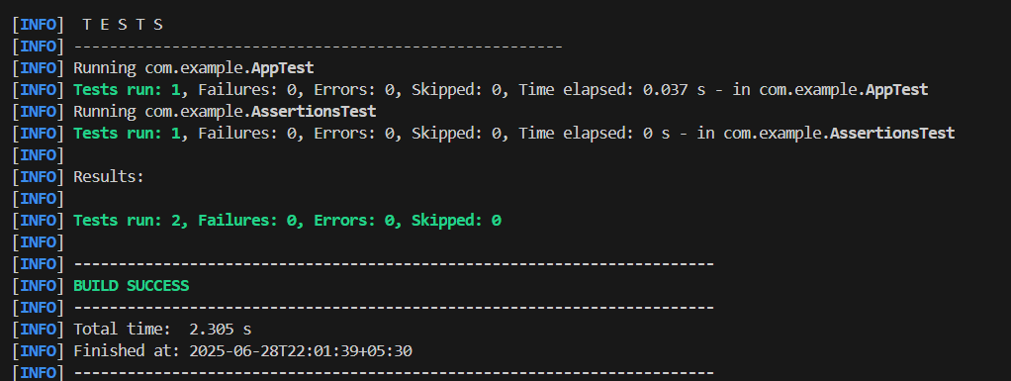

**Exercise 4: Arrange-Act-Assert (AAA) Pattern, Test Fixtures, Setup and Teardown Methods in Junit**

|  |  |
| --- | --- |
| Calculator.java  package com.example;  public class Calculator {      public int add(int a, int b) {          return a + b;  }  public int subtract(int a, int b) {          return a - b;      }  } | CalculatorTest.java  package com.example;  import org.junit.After;  import static org.junit.Assert.assertEquals;  import org.junit.Before;  import org.junit.Test;  public class CalculatorTest {      private Calculator calc;      @Before      public void setUp() {          //Arrange          calc = new Calculator();          System.out.println("Setup complete");      }  @After      public void tearDown() {          System.out.println("Test completed");      }  @Test      public void testAdd() {          //Act          int result = calc.add(2, 3);  //Assert          assertEquals(5, result);      }  @Test      public void testSubtract() {          int result = calc.subtract(10, 4);          assertEquals(6, result);      }  } |

**OUTPUT:**

